Parent Book Recommendations:

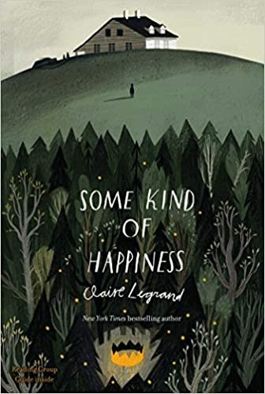

This looks a bit older but I might get it. It has journaling exercises in it

This story has a character with dark fears who has to save herself in order to save others

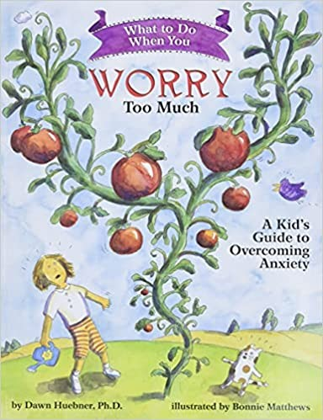

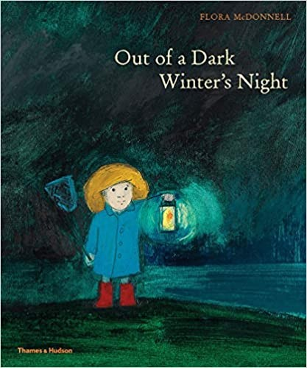

This is about facing the dark night and seeing the dawn

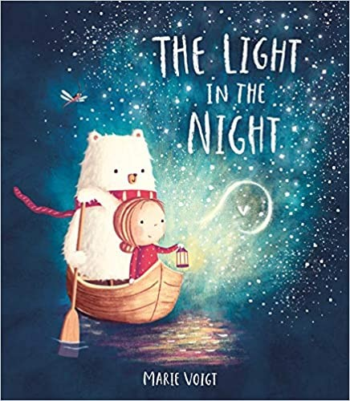

This is about how you need the dark to see the moon, make shadows with your hands and see the stars. I'll use this as the basis to make up our own story.